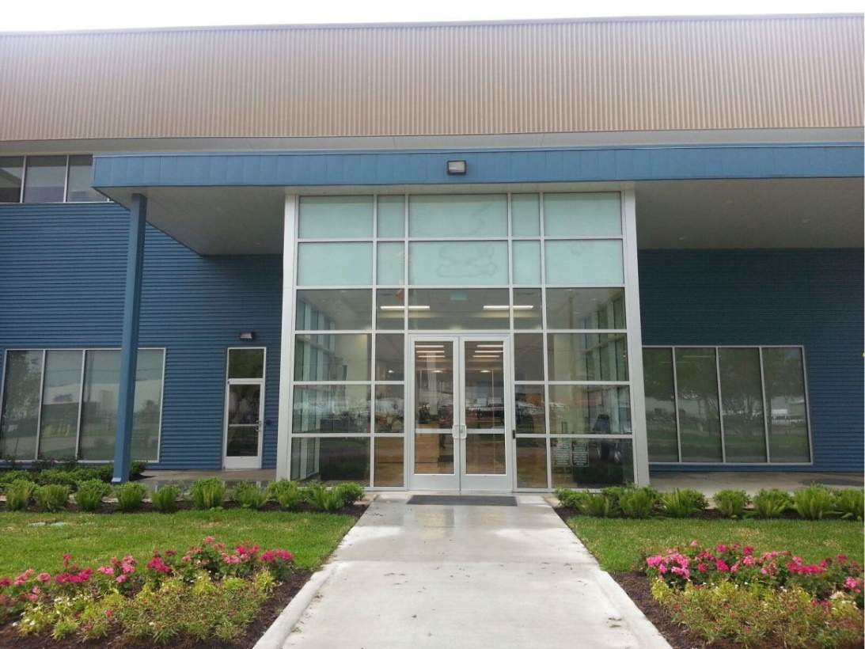

Houston Learning Center Guidebook

Table Of Contents
About Houston Learning Center 3
Purpose 3
Key Contacts - Training 4
Key Contacts - Logistics 5
Staff and Student Commitment 6
EHS Policy 8
Quick Reference Guide 8
Site Specific Safety Training/Orientation 10
PPE (Personal Protective Equipment) 11
(POWRA) Point of Work Risk Assessment 11
Emergencies At HLC 13
Incident Reporting 14
Find It-Fix It 16
LOTO 19
Chemical Management 21
Waste Disposal 22
Survival Basics 24
Notes 31
Notes 32

About Houston Learning Center

In 2014, GE Power Services Training Division recognized an opportunity for growth and began the task of repurposing an existing GE owned property which was formerly utilized as the GE Houston Service Center. The 15-acre campus has been revitalized to accommodate product line training areas including Aeroderivitives, Controls, Excitation, Gas and Steam Turbine, Generator, Global Installation and Commissioning, and I&LES. Located at 8800 Wallisville Road in Houston, Texas, the Power Service Training Center’s versatile functionality is able meet the needs of both customer and internal training requests for a variety of students ranging from entry to advanced level experience.
The Houston Learning Center (HLC) has been carefully designed to accommodate the volume of up to 400 students per day expected during peak training time. All of the space within the three main buildings, ranging from 45,000 to 20,000 square feet in size, has been optimized to provide the best possible hands on and in classroom training experience. Building one is currently fully operational and houses 9E, 7E, 7F and D11 Heavy Duty equipment in the bays as well as state of the art customer and internal classrooms located throughout the building. Building two is currently still under partial renovation and will house Installation and Commissioning equipment as well as other opportunities for training. Building three is also fully operational and has areas dedicated to Aeroderivitives, Controls and Excitation.
The Power Service Training Center is proud to be in a city nicknamed the “Energy Capitol of the World”. Home to more than 5,000 energy related businesses, Houston, Texas is an ideal location to provide training to the global community of General Electric. Its rich culture and diverse population provide an excellent opportunity for students to experience a variety of cultural opportunities while receiving state of the art training.

Purpose

The GE Houston Learning Center's mission is to provide high quality training programs to the GE Power Businesses and Customers.
The following guidelines have been established to help us accomplish our job. Course instructors or HLC Staff are responsible for making sure all students, visitors, or meeting participants are adhering to these guidelines.

Key Contacts - Training
Training Delivery Manager - Jim Rosen 832-714-2496
Controls
Product Line Lead – Greg Walker 936-520-0397
Jim Lin 281-254-1472
John Doss 281-384-0888
Gas Turbine
Product Line Lead – Sherif Khalifa 281-387-4979
Jimmy Capps 936-222-9713
Greg Jackson 281-658-8433
Lou Baez 813-389-8810
Steam Turbine
Product Line Lead – Pablo Schibli +41 (78) 8787173
Aaron Curtis 361-816-8194
Ken Ferrari 713-672-3770
Excitation/Generator
Product Line Lead - Michele Alcantar 832-926-0238
Ben Smith 513-646-5243
Julio Ramirez 281-254-5589
Aero
Product Line Lead – Greg Walker 936-520-0397
Roland de Conceicao 713-672-3771
Douglas Salazar 832-606-8779

Craft/Repairs
Product Line Lead – Harry Hanson 630-561-5231
Victor Fuentes 281-217-5421
Lucian Cote 603-631-5216

Key Contacts - Logistics
Global Logistics Leader - Andrew Ruch 281-229-5417
OE Project Manager – Maria Medina 713-597-1935
Training Coordinator Internal Enrollment – Marisol Guidry 832-998-4104

Staff and Student Commitment

STUDENT: It is important that I work to the best of my ability. Therefore, I will commit to do the following:
- Work Safely. No compromises.
  - Understand and comply with all posted signs, SRAs, work instructions, etc.
  - Actively participate in Safety Task Assessments (STA) hazard hunts, etc. as required
  - Report any concerns to EHS, Instructors or Management
  - If in doubt, ask before do!
- Act with Integrity. 100% commitment and compliance to The Spirit & The Letter. (http://integrity.ge.com)
- Respect your peers, training staff, and equipment.
- Be Punctual. Arrive on time, or report issues to instructors as soon as practical.
- Be Prepared. Come to work each day with assignments complete, be ready to learn, and participate.

INSTRUCTORS: It is important that students achieve. Therefore, I will commit to do the following:
- Work Safely. No compromises.
  - Ensure adherence to all EHS policies by ALL personnel.
  - Understand and comply with all posted signs, SRAs, work instructions, etc.
  - Ensure STAs are completed for all required activities
  - Report any concerns to EHS or Management
  - If in doubt, ask before do!
- Act with Integrity. 100% commitment and compliance to The Spirit & The Letter.
- Provide instruction and leadership.
- Demonstrate care and concerns for each student.
- Respect your peers, students, and equipment.
- Make efficient use of academic learning time.
- Provide an environment that allows for positive communication.

PRODUCT LINE LEADERS / MANAGERS: We support this form of involvement. Therefore, we shall strive to do the following:
- Provide a safe environment for all.
- Provide an environment that allows for positive communication between managers, instructors, and student.
- Make informed decisions with input from many sources that will benefit the business and all students.

Are you committed to our rules? Place your signature here: ________________________

I Commit to Safety
Working together as a team, to promote the safety of the team!
- Safety is my #1 top priority.
- I will protect my environment.
- My customer determines my success.
- I will wear my PPE while on the job.
- I will report all incidents, near misses, and unsafe conditions.
- I will comply to written and verbal procedures and instructions.
- I will be the best example of compliance and regulatory excellence.
- I have Stop Work authority for all tasks, situations and people on site.
- I will produce quality work and will not accept, create, or pass any defects.
- I will be a clear thinker and use my knowledge and experience to make good decisions.
- My professionalism and positive attitude directly affects the success of this outage.
- My expertise and skill will lead to intelligent and improved innovations.
- I will be alert, understand my task, and evaluate existing circumstances.
- I commit to fully understand and adhere to the LOTO program.
- I can save a life today. I will not look away.

EHS Policy

What do I need to remember?

Employee Responsibilities:
- Follow this policy, applicable laws and regulations and all other HLC's EHS policies, procedures and rules to protect your own health and safety as well as that of other workers, the public and the environment.
- Know and support the annual EHS goals of our organization.
- Promptly raise any concerns about possible unsafe conditions, activities or violations of this policy to your supervisor, local EHS team, or other GE Power or One EHS team, Medical Services, legal counsel, or another designated person. Your report may be written or oral, and it may be anonymous.
- Stop immediately and escalate any work that poses imminent danger hazards to yourself, your co-workers, contractors or the community.

EHS is everyone’s responsibility.
This policy is signed by Power Services Business Leader and can be found posted on the EHS Board, throughout the departments and on the PS Training Student Portal.

Quick Reference Guide

This handbook contains a variety of safety information to help increase your safety awareness; it is not intended to be a complete safety manual. To perform work safely, other safety procedures and references may need to be reviewed.

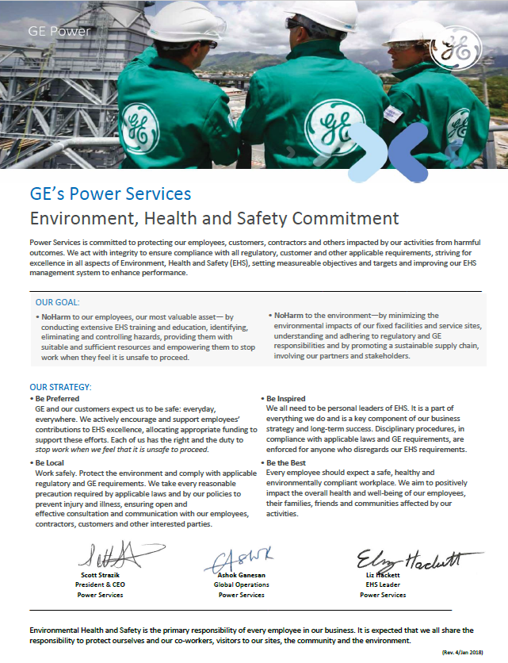

Site Specific Safety Training/Orientation
Upon Arrival to the site you will be asked to watch a short safety video. Please do so as it gives you a basic overview about HLC and safety rules in the campus. If you haven’t watched a safety video please contact your manager, instructor or host. We will organize it shortly.
All visitors to HLC will be required to sign in as indicated at the building entrance and acknowledge receipt of the HLC Site Rules Card. Security shall verify receipt of the card and sign-in. The Site Orientation Cards cover basic site safety rules that must be followed while at the HLC.
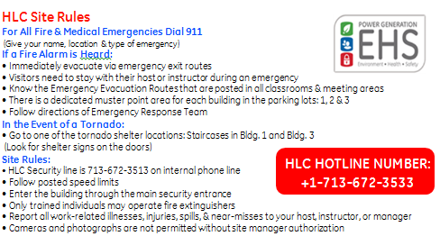
Prior to student entry into HLC labs, Web Based Training (WBT) completion will be verified by EHS Dept. A completion report will be sent to instructors, indicating students’ progress on WBT training.
All classroom training will be documented via a class roster, which should include the subject, trainer, date, and all employees in attendance.
Students who have not completed WBT or Instructor Led Training will not be allowed to participate in lab training.
Students who arrive late will be required to complete all EHS training before being permitted to enter HLC labs. The EHS training will be conducted through either a third-party provider, scheduled WebEx sessions, and/or delivered by the EHS Training Instructor. Method of delivery is dependent upon scheduling, availability and third-party vendor approval.
The student can attend the Instructor Led Training in region prior to arrival at the HLC and provide sufficient proof of completion. This will be verified by EHS Training Instructor.

PPE (Personal Protective Equipment)
PPE will be worn when necessary to protect employees and students against hazards that cannot be practically eliminated or controlled. Whenever there is a change in working conditions that presents new or different hazards, the Instructor or Supervisor will ensure that work areas and tasks are reassessed to identify any new PPE requirements and will provide suitable protection as necessary. Where PPE is specified, compliance with its use is mandatory. All employees who use PPE will receive appropriate training on PPE selection, use, care and maintenance.
- Safety glasses with side shields must be worn at all times in training bays and lab areas.
- Substantial footwear (a shoe that completely encloses the foot) must be worn at all times in training bays and lab areas even within the yellow lines.
- Safety shoes must always be worn outside the yellow lines.
- Hard hats must be worn when overhead work is being performed.
- Additional PPE such as hearing protection, gloves, and additional eye protection must be worn in designated areas or when performing designated tasks.
- Refer to the Safety Risk Assessment (SRA) for the task you are performing to determine the required PPE.


- Do not wear clothing or jewelry which could get caught in machinery or otherwise cause accident or injury.
When entering the lab areas, you will see PPE requirements posted on the door. Please read those and comply. You will find boxes with safety glasses in various locations, so you can always wear an eyewear if you forgot yours.

(POWRA) Point of Work Risk Assessment
A POWRA must be developed and made available for each job task performed at HLC.
This is intended to analyze the task at hand to analyze the best method to perform the task safely. It includes both routine and non-routine tasks and activities. We find when we review and plan for a task, we stay safer - whether it is routine or non-routine.
The use of these STAs has proved very beneficial and works - please use them! Upon completion of your task please return POWRAs back to EHS Manager, Facility Manager or your Instructor.


Emergencies At HLC

Emergency Preparedness forms part of the Emergency Management Cycle. By preparing for the worst, we can work to prevent it from happening, and react efficiently in the event of an emergency occurring. The Emergency Management Cycle consists of:
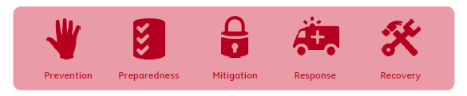
Actions on Discovering a Fire

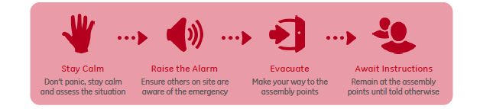
One of the most likely emergencies is a fire. Fire devastates workplaces and has the potential to claim lives and property. It’s important that you know exactly what to do in the event of discovering a fire. Follow the instructions below:
Actions on Discovering a Spillage
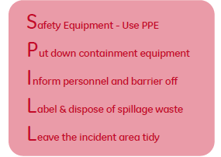
Spillages in the workplace can be detrimental to both Health & Safety and the Environment. If a spillage is left unattended to, it could cause a slip, trip or fall, or a vehicle to skid. If a spillage is not contained, it could leak into the main water system, causing environmental damage.
If you do spot a spillage, or witness a spill occur, it’s important you know exactly what to do. Remember the acronym S.P.I.L.L.
Actions on Discovering a Medical Emergency

When someone becomes unwell on site, or becomes injured during work hours, it may be necessary to either seek professional help, or evacuate them from site.
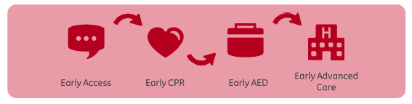
It’s important to get the right help to the casualty, call for professional assistance from the emergency services if necessary. You should remember the chain of survival:
- In an emergency, employee/student/visitor must seek medical attention immediately, by calling First Aid (dial +1 (713) 672-3533 or 911). Numbers are also posted in each phone and throughout the departments.
- If not an emergency, contact EHS (dial +1 (713) 672-3564) prior to seeking medical attention.

Incident Reporting

Accident reporting is an OSHA regulatory requirement. It is important to report them so they can be investigated to determine root cause and follow-up actions to resolve the current issue and prevent future incidents from occurring.
What you need to know
- All incidents (injuries, near misses, events) need to be reported to your Instructor, Supervisor or EHS immediately within a day when it occurred.
- A team approach will be used to conduct an incident investigation, including the element champion, EHS, injured employee and instructor/supervisor.
- All cases are documented and follow-up corrective & preventive actions tracked to closure.
- Safety Notification or EHS communications are used to share incident details and lessons learned with all employees through EHS and/or supervisors, EHS Communication Board and Safety Newsletters.
- In the beginning of each year, HLC posts OSHA Annual Summary of Work-Related Injuries and Illnesses (Form 300A) in the lunch room, break rooms and online on the EHS Training Student Support Central website.
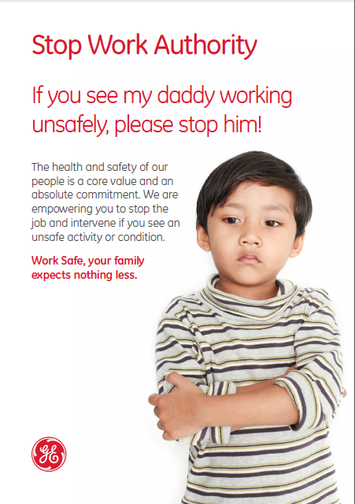

Find It-Fix It
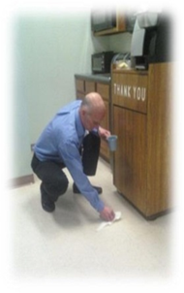
What is this program?
This is an EHS Incentive Program where you “self-report” actions you have taken to correct potential safety issues.
How does it work?
If you see a potential safety concern, and if it is minor and you can safely correct it on the spot, - you “fix it” – OR – you notify your Instructor, Host or Facilities Lead.
Then What?
You fill out a card with your name, phone number and the action you took and place it in one of the receptacles around the building. Cards and receptacles are located in Classrooms, Labs, Safety Awareness Area or at Reception Counter.

Why?
EHS is everyone’s responsibility. If you see a potential safety issue that you can safely correct or you notify your Instructor or Facilities Lead to correct the issue, you are being a Safety Ambassador and helping keep the HLC a safe place to work. By correcting these issues immediately, you can prevent your fellow co-workers from possibly being injured.
Each month EHS will communicate the actions people have taken to make the HLC a safer place to work – AND- one card will be drawn for a prize.
Examples of Items you can correct yourself:
- You notice a carpet is rumpled or the edge is flipped up – you straighten out the carpet so no one trips
- You see a puddle of water on the floor and you wipe it up so no one slips
- There is an icy patch outside one of the doors and you put some ice melt from the self-service bins on it
- You move a small empty box blocking a fire extinguisher
- There is a cord running across a conference room and you move it so no one trips

Do you have an eye for detail and a passion for safety?
Try HLC's EHS “Find It –Fix It” program!

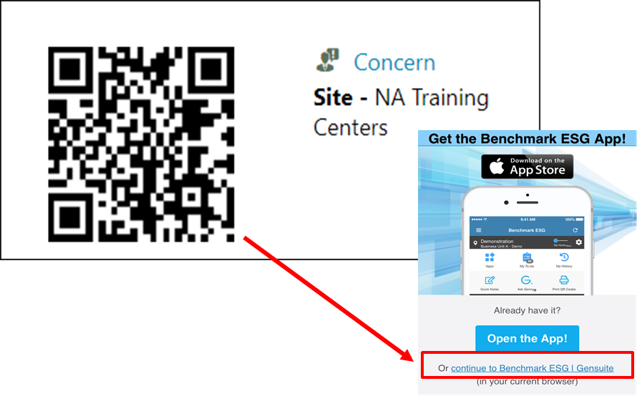

This page intentionally left blank

LOTO
The Lockout Tagout (LOTO) program was designed to prevent injuries caused by unexpected activation of hazardous energies. Unexpected release of hazardous energy can include any unintended motion, energization, start-up or release of stored energy, deliberate or otherwise, from the perspective of the person(s) at risk.
What you need to know
- Only Authorized Employees shall perform LOTO: Facilities and Lab Instructors.
- All other HLC employees are considered Affected Employees. They must be notified when LOTO will be performed and be able to recognize LOTO devices.
- NEVER remove any LOTO device in use.
- Contractors shall not use or perform maintenance on GE HLC equipment without specific GE HLC approval. The Contractor will be required to attach and secure individual red LOTO locks and red tags to the same energy-isolating devices. This is commonly known as “GE first on/last off”. All Contractors will be under the direct supervision of an HLC LOTO Authorized employee.

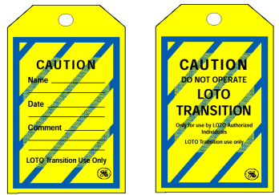

HLC LOTO Locks and Tags:
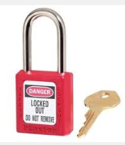
Individual LOTO Locks/Tags Transition LOTO Locks/Tags

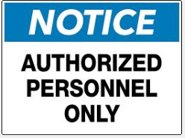
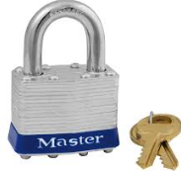
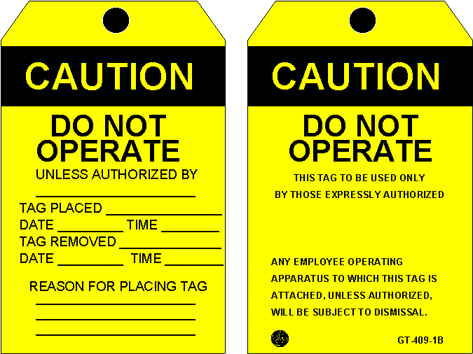Instructors “Safe to Operate” Locks/Tags Out of Service Maintenance Locks

Additional type of Group Locks (usually black) can be used for Training Purposes only when Equipment Outage is in progress.
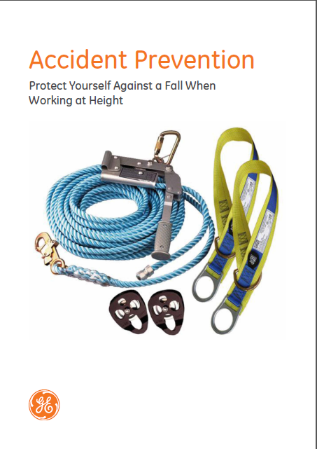

Chemical Management

The Chemical Management program focuses on reducing employee’s exposure to chemicals that pose flammable, carcinogenic or other unfavorable qualities.
What you need to know
- Lab Students, Instructors and Employees shall receive annual training on Hazardous Chemicals in the Workplace to ensure they understand the hazards and signs of overexposure of commonly used chemicals.
- Safety Data Sheet (SDS) provides guidance for the safe use and emergency contingencies for a particular substance. They are routinely stored online in the Gensuite SDS repository and will be made ready available.
- All chemicals must be pre-approved by EHS prior to use in our campus. The Approved Chemical List is available in the Gensuite SDS repository.
- Employees must assure that every chemical container they use is labeled with chemical name and hazard information.

- Periodically inspections are conducted to verify all chemicals are in compliance with these requirements.
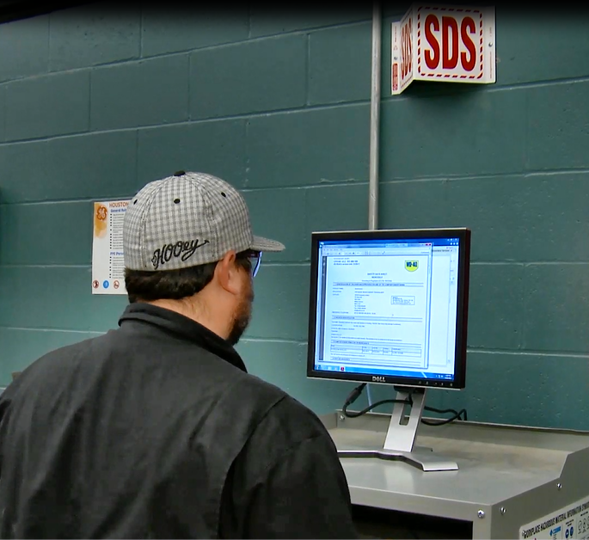
HLC has several electronic SDS stations throughout the site:
- In Building 1 for Gas Lab
- In Building 1 for Steam Lab
- In Building 3 for Aero Lab, EE Lab and Controls Lab
Hardcopies of SDSs for each location can be found near the computer SDS stations.

Waste Disposal
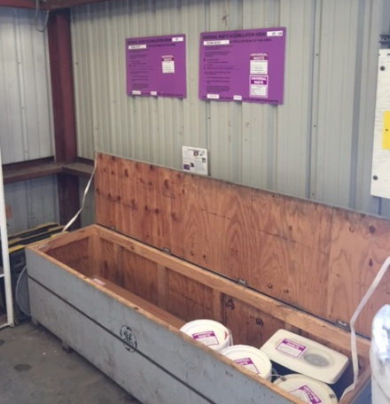
The Waste element goal is to ensure compliance with all applicable waste management regulations. It establishes an inventory of all waste generated and processes to ensure proper disposal.
What you need to know
Types of regulated waste generated at HLC are:
Universal waste: batteries, lamps, paint waste.
- Segregated based on type
- Labeled: Universal Waste, type of waste, and accumulation start date
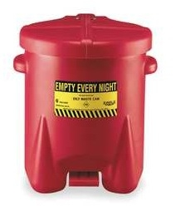
- Containers structurally sound to prevent breakage or leakage of materials and kept closed except when adding or removing waste
Oily soaked materials: to be collected and placed into the red bin. These bins are located around the lab areas and cleaned up on a weekly basis. Do not place into the bin rags or wipes containing solvents or other non-related materials.
Hazardous waste: empty aerosol cans, out-of-date chemicals, broken lamps.
- Generated mainly in the labs
- Collected in satellite accumulation areas (SAA) close to generation points in the labs
- Labeled Hazardous Waste, type of waste, generator information
- Moved to hazardous waste storage area by lab techs only when full
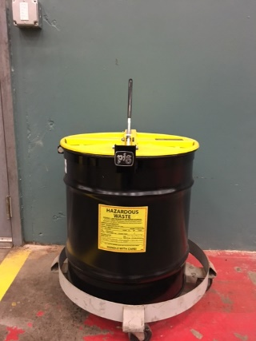
- Manifest can only be signed by trained staff
Solvent Contaminated Wipes to be placed only into the drum marked with “Solvent Contaminated Wipes”.
There are other types of waste that can be generated on site. Please check with your manager, instructor or host if unsure.
Remember: No chemicals can go down any sink, floor or storm drains. This includes: runoff from equipment cleaning and cement truck wash downs.
GE will manage all waste, including excavated material generated during your project. Facilities and EHS will coordinate all waste activities. The Contractor will not remove any hazardous waste from the site. Any waste generated by you or your project will need to be discussed ahead of time with the EHS Manager for proper waste management and disposal.
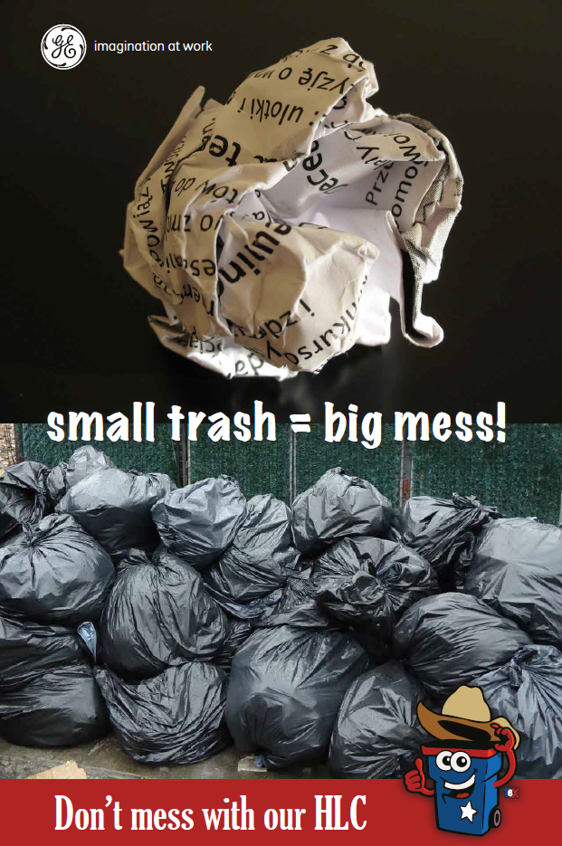

Survival Basics


Badges/Work Hours
The normal business hours of HLC are from 7:30 a.m. and 4:30 p.m.
The Center is equipped with an electronic security system. Special arrangements can be made if it is necessary to be in the building after hours. Students must be supervised by a GE HLC employee outside normal business hours when in the building.
All visitors will be badged and escorted as required.
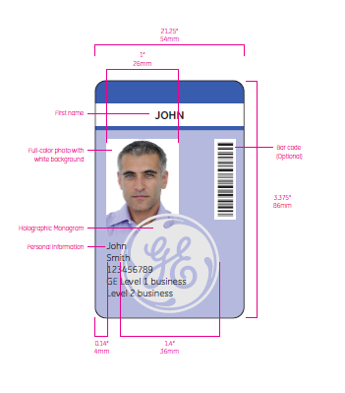

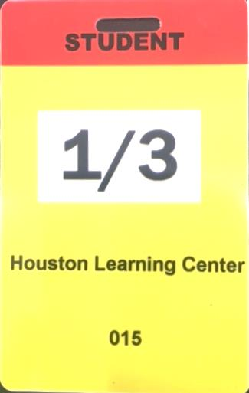
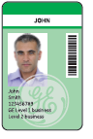
Contractors Visitors Students Contractors (Temporary)
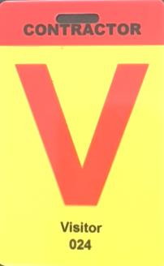
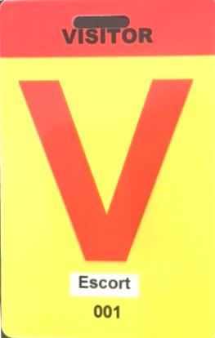


Dress Code
The GE HLC is a place of business devoted to the training needs of GE. Employees are expected to dress and conduct themselves accordingly. The attire at the Center should be appropriate for the situation. As a guideline, we have established the following dress code:
Classroom Training
Business / Smart Casual attire is advised. The following are not permitted:
- Torn, dirty, stained, or tie-dyed clothing
- Nothing with writing or advertising
- Shorts or cut-offs
Lab Operations
Refer to PPE section of this Handbook.
Photo / Graduation (if applicable)
- Business Professional attire
Please be compliant as there are no exceptions.

Holidays
Houston Learning Center is closed on the following days:

- New Year’s Day
- Martin Luther King Jr. Day
- President’s Day
- Good Friday
- Memorial Day
- Independence Day
- Labor Day
- Veterans Day
- Thanksgiving Day
- Day after Thanksgiving
- Day before Christmas Eve
- Day after Christmas


Parking Lot
Please follow all posted speed limits and other traffic signs. Speed limit at HLC is 10mph. Please turn off engine on your vehicle if stop time exceeds 5 minutes.
On the first day all students must enter the building through the Main Security entrance in Building 1 for registration purposes.
Students shall park on Student’s parking lot area located on a West side. Visitors may park upfront of Building 1. Refer to “General Layout and Muster Points Map” below to get acquainted.
Reversed parking is advised. You may also want to sound your horn twice before backing up to let people aware of your intentions.

Office Supplies/Printer Set Up
A printer / photo copier is in Building 1, 1st floor for student / visitor use.
To install the HLC printer you can do so by either of these two ways depending on your Network connection.
If you can access the BLUESSO Network, click on the link below to install printer HLC_Xerox_BLDG_1 located on the first floor.
\\avnfwp0237v02\HLC_Xerox_BLDG_1
If you can only access the guest Internet Network, click on the link below to install the first floor printer.
\\3.14.23.73\
On the resulting window grouped in alphabetical order, find HLC_Xerox_BLDG_1 and double click its icon.
If any assistance is needed to connect to a local printer please ask your instructor or host. They will get in touch with IT Specialist and the issue will be resolved.
If you are looking for any office supplies (pens, notebooks, etc.) we are happy to help you with it as well. Please contact the reception desk for assistance.


Internet
HLC has Wi-Fi coverage around the campus and in the labs.
Standard Wi-Fi called “Internet”. Password is: Acc3ssGr@nted
GE employees can also connect to BLUESSO by logging in with their SSO and SSO Password.


Deliveries/Shipments
If you need things mailed or shipped to you while you are here, please use the following information:
GE Houston Learning Center
Your Name
Your Class Name
8800 Wallisville Road
Houston, TX 77029
If you need to send or ship something while you are here please contact the reception desk. No postage is necessary if you are mailing through the US Post Office to a GE Office location. All other mail will require postage at your expense.
All UPS, Fed Ex, DHL shipments are to be at your own expense or that of your Manager, at his/her discretion.


Events
Throughout the year, the HLC staff will host various activities on site. There are also many opportunities to participate in volunteer and other community programs in the local area. All students and visitors are encouraged to participate in these activities. For more information about schedules and opportunities, please contact your instructor or host.


Food and Drinks
Food and open drink containers are only allowed in designated areas and not allowed in the labs.
HLC has several break rooms on a campus. They are all equipped with drinking water, coffee and tea. Choice of snacks and beverages is available in vending machines.
Abby’s Café is in Building 1. The Café is open 7am – 1pm Monday – Friday. They accept cash and credit cards and offer a choice of hot entrees, sandwiches, salads, snacks and drinks.

Smoking
To ensure the safety of our staff and customers, the HLC has established a designated smoking area on the Southwest corner of the property, behind building 3. This exception to our non-smoking policy aims to prevent individuals from crossing traffic and standing on a busy road. We want to provide a safer alternative for smokers without condoning smoking. Signage clearly indicates the area's purpose without overtly promoting smoking. We kindly request smokers to confine smoking to this designated area, dispose of cigarette butts properly, and be considerate of others. Our goal is to maintain a respectful and harmonious environment for everyone.
Smoking is prohibited in all vehicles while on campus. Tobacco use is also prohibited at all times in company vehicles. (This includes vehicles provided to employees for private use.)
No loitering!

Cameras / Cell Phone Cameras
Cameras are not permitted without authorization. Camera use must be cleared through Campus Security. Non-approved cameras will be held at Main Reception. GE employees and visitors are not to use cell phones with cameras to take pictures of any company facilities, equipment, or information. Any cell phone suspected of being used to take photographs on Campus is subject to seizure and examination.
Do not use your phone while you are performing work in the lab areas. For your personal safety please avoid texting and talking while walking.

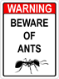
Be Wary of Insects
The HLC is professionally treated for pests regularly, however it is not uncommon to find various insects in and around the facility. Most of these insects are harmless, but you may find fire ants, especially in grassy areas and after heavy rain. Fire ants react to perceived threats by attacking in swarms. Their stings can be very painful and some people may suffer allergic reactions. It is best to avoid grassy areas and if you see an ant mound or any other signs of insect activity, avoid it and inform HLC staff immediately.


General Layout and Muster Points Locations
If the evacuation alarm sounds, leave the building immediately and assemble to the nearest muster point located on the map. In Case of Emergency Dial 911
HLC Status line is 877-672-3771 or 713-672-3509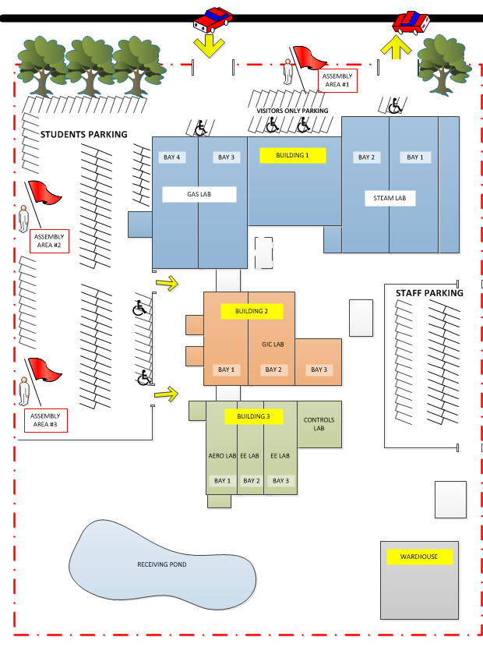

Notes
________________________________________________________________________________________________________________________________________________________________________________________________________________________________________________________________________________________________________________________________________________________________________________________________________________________________________________________________________________________________________________________________________________________________________________________________________________________________________________________________________________________________________________________________________________________________________________________________________________________________________________________________________________________________________________________________________________________________________________________________________________________________________________________________________________________________________________________________________________________________________________________________________________________________________________________________________________________________________________________________________________________________________________________________________

Notes
________________________________________________________________________________________________________________________________________________________________________________________________________________________________________________________________________________________________________________________________________________________________________________________________________________________________________________________________________________________________________________________________________________________________________________________________________________________________________________________________________________________________________________________________________________________________________________________________________________________________________________________________________________________________________________________________________________________________________________________________________________________________________________________________________________________________________________________________________________________________________________________________________________________________________________________________________________________________________________________________________________________________________________________________________


